Chapter-16 Part-4

Aplia Homework: Externalities, the Environment, and Natural Resources

**1. The effect of negative externalities on the optimal quantity of consumption**

Consider the market for steel. Suppose that a steel manufacturing plant dumps toxic waste into a nearby river, creating a negative externality for those living downstream from the plant. Producing an additional ton of steel imposes a constant incidental cost of $525 per ton. The following graph shows the demand (marginal private value) curve and the supply (marginal private cost) curve for steel.

Use the purple points (diamond symbol) to plot the marginal social cost curve when the incidental cost is $525 per ton.

**Note**: Plot your points in the order in which you would like them connected. Line segments will connect the points automatically.

The market equilibrium quantity is ______ tons of steel, but the socially optimal quantity of steel production is ______ tons.

To create an incentive for the firm to produce the socially optimal quantity of steel, the government could impose a _____ of _____ per ton of steel.

**2. Basic approaches to environmental policy**

Carbon-dioxide emissions have been linked to worsening climate conditions. The following table lists some possible approaches to reducing the amount of carbon dioxide in the air. For each approach, use the dropdown menu to identify whether it is a command and control policy (regulation), a pollution tax, an emissions permit system, or a system of voluntary compliance.

| **Environmental Policy** | **Type of Approach** |
| --- | --- |
| The government charges factories $100 for every ton of carbon dioxide they emit. | **______________** |
| The government limits total carbon-dioxide emissions by all factories to 100,000 tons per year by selling rights to emit to the highest bidders, with the price determined by demand and supply. | **______________** |

**3. Market solutions to correct for negative externalities**

This problem asks you to examine the costs in the market for gasoline.

The cost of consuming gasoline comes in two parts:

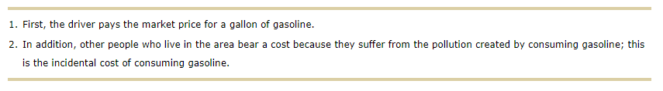

Because incidental costs result from the consumption of gasoline, the marginal social cost of gasoline exceeds the marginal private cost.

The following graph shows the demand (marginal private benefit, or MPB) for gasoline, the marginal private cost of a gallon of gasoline, and the marginal social cost of producing and consuming gasoline.

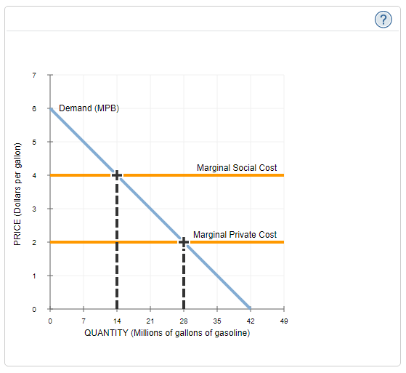

According to the graph, if the government does not intervene in the market for gasoline, the equilibrium price of a gallon of gasoline will be **____**, and drivers will buy **____** million gallons.

Which of the following statements correctly describe the market for gasoline? Check all that apply.

At the market quantity, the marginal private cost of gasoline exceeds the market price.

The market outcome is not socially efficient.

The marginal social cost of gasoline is greater than the marginal private cost.

Society prefers that more than the market output of gasoline be produced.

Suppose that government regulators try to deal with the pollution externalities by imposing a binding limit on the quantity of gasoline that can be sold. Together, producers in this market can sell a maximum of 14 million gallons.

This intervention _______ correct the pollution externality.

Now, suppose that the government decides not to use quantity limits. Instead, it imposes a tax on gasoline.

According to the previous graph, in order to achieve the efficient quantity of gasoline, the government should impose a tax of _______ per gallon.

Both the tax and the quantity restriction policy are solutions to pollution. Based on the previous graph, which policy is more successful in ensuring that the efficient quantity of gasoline is consumed, and that the people who consume it are those who derive the most value from it?

The tax

Both policies are equally successful

The quantity restriction system

**4. Correcting for negative externalities - Regulation versus tradable permits**

Suppose the government wants to reduce the total pollution emitted by three local firms. Currently, each firm is creating 4 units of pollution in the area, for a total of 12 pollution units. If the government wants to reduce total pollution in the area to 6 units, it can choose between the following two methods:

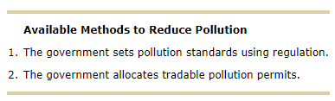

Each firm faces different costs, so reducing pollution is more difficult for some firms than others. The following table shows the cost each firm faces to eliminate each unit of pollution. For each firm, assume that the cost of reducing pollution to zero (that is, eliminating all 4 units of pollution) is prohibitively expensive.

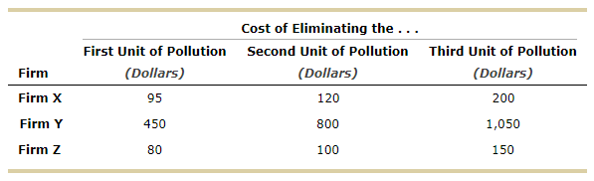

Now, imagine that two government employees propose alternative plans for reducing pollution by 6 units.

**Method 1: Regulation**

The first government employee suggests limiting pollution through regulation. To meet the pollution goal, the government requires each firm to reduce its pollution by 2 units.

*Complete the following table with the total cost to each firm of reducing its pollution by 2 units.*

| **Firm** | **Total Cost of Eliminating Two Units of Pollution** |
| --- | --- |
| ***(Dollars)*** |
| **Firm X** | $ _____ |
| **Firm Y** | $ _____ |
| **Firm Z** | $ _____ |

**Method 2: Tradable Permits**

Meanwhile, the other employee proposes using a different strategy to achieve the government’s goal of reducing pollution in the area from 12 units to 6 units. He suggests that the Government Issue two pollution permits to each firm. For each permit a firm has in its possession, it can emit 1 unit of pollution. Firms are free to trade pollution permits with one another (that is, buy and sell them) as long as both firms can agree on a price. For example, if firm X agrees to sell a permit to firm Y at an agreed-upon price, then firm Y would end up with three permits and would need to reduce its pollution by only 1 unit, while firm X would end up with only one permit and would have to reduce its pollution by 3 units. Assume the negotiation and exchange of permits are costless.

Because firm Y has high pollution-reduction costs, it thinks it might be better off buying a permit from firm Z and a permit from firm X, so that it doesn't have to reduce its own pollution emissions. At which of the following prices is firm Z willing to sell one of its permits to firm Y, but firm X is not? Check all that apply.

$90

$178

$186

$451

$529

Suppose the owners of the three firms get together and agree on a trading price of $326 per permit.

Complete the following table with the action each firm will take at this permit price, the amount of pollution each firm will eliminate, and the amount it costs each firm to reduce pollution to the necessary level. If a firm purchases two permits, assume that it buys one permit from each of the other firms. (**Hint**: Do not include the prices paid for permits in the cost of reducing pollution.)

| Firm | Initial Pollution Permit Allocation | **Action** | Final Amount of Pollution Eliminated | CostofPollutionReduction |
| --- | --- | --- | --- | --- |
| *(Units of pollution)* | *(Units of pollution)* | ***(Dollars)*** |
| Firm X | 2 | **_________** | **_________** | **$ ________** |
| Firm Y | 2 | **_________** | **_________** | **$ ________** |
| Firm Z | 2 | **_________** | **_________** | **$ ________** |

**Regulation Versus Tradable Permits**

*Determine the total cost of eliminating six units of pollution using both methods, and enter the amounts in the following table. (****Hint****: You might need to get information from previous tasks to complete this table.)*

| **Proposed Method** | **Total Cost of Eliminating Six Units of Pollution** |
| --- | --- |
| ***(Dollars)*** |
| Regulation | $ ___ |
| Tradable Permits | $ ___ |

In this case, you can conclude that eliminating pollution is _______ costly to society when the government distributes tradable permits than when it mandates that each firm eliminate a certain amount of pollution.

**5. Non-renewable resources**

Consider the fictional non-renewable resource elastoleum. Once prevalent throughout the world, the world supply of elastoleum had been reduced to a mere 4,500 barrels by 2016.

The following graph shows supply curves of extracted elastoleum from 2016 to 2018, along with the yearly demand for elastoleum. Assume that technology is constant and that no new elastoleum deposits are discovered during these years.

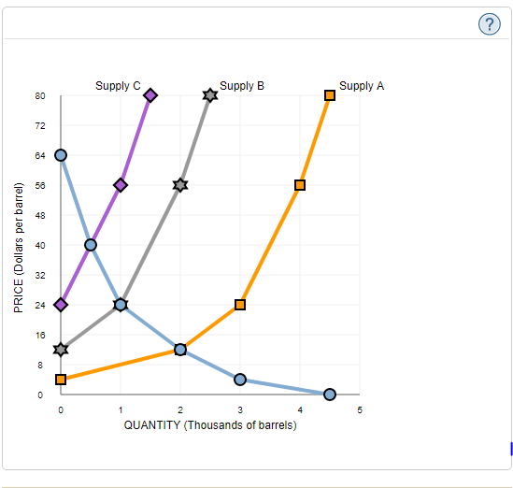

Which of the supply curves is most likely to represent the supply of extracted elastoleum in 2018?

Supply A

Supply B

Supply C

On the following graph, use the black points (plus symbol) to plot the equilibrium price of elastoleum for the years 2016, 2017, and 2018.

**Note**: Plot your points in the order in which you would like them connected. Line segments will connect the points automatically.

In practice, the prices of some finite resources have remained constant over the years. Which of the following may cause the price of elastoleum not to change? Check all that apply.

The government implements a price ceiling on elastoleum.

A new technology makes extraction of elastoleum cheaper.

A new reserve of elastoleum is discovered.